**Name:** Henry Salgado

**CS 4351/5352: Computer Security**

**Assignment 2**

**a. (5 points) List all the attributes that are stored for an individual user in a shadow file.**

This is an example of how a shadow file would like for a user in Linux:

**johndoe:$6$trp4O9fA$K1D5OnBx8t7Zw8KZwp3Rz/c0D9dkT5aJ.wxyzABCDEF12345GH6:18234:0:99999:7:::**

* **Username:** johndoe - The user's login name.
* **Password:** $6$trp4O9fA$K1D5OnBx8t7Zw8KZwp3Rz/c0D9dkT5aJ.wxyzABCDEF12345GH6 - The encrypted password. The $6$ prefix indicates that the hashing algorithm used is SHA-512. Following this prefix, trp4O9fA is the salt value, and the rest is the hashed password.
* **Last password change:** 18234 - The number of days since January 1, 1970, the password was last changed. This is an example value.
* **Minimum password age: 0 -** Indicates there's no minimum age before which the password cannot be changed.
* **Maximum password age: 99999 -** The password does not need to be changed for a very long time, effectively never expiring.
* **Password warning period: 7 -** The user will be warned 7 days before their password expires to change it.
* **Password inactivity period:** The field is empty in this example, indicating that there's no specific inactivity period set.
* **Account expiration date:** The field is empty, showing that the account does not have an expiration date set.
* **Reserved field:** Also empty in this example.

**b. (5 points) Where do the passwords in Windows system get stored?**

Password storage in windows is a bit different than in Linux.

1. For local accounts on a Windows, passwords are stored in the SAM database.
2. For systems that are part of a Windows domain, the passwords for domain accounts are stored in the Active Directory database.
3. For usernames and passwords, credentials are stored in an encrypted format in the Windows Vault, for the current user and %SystemRoot%\system32\config\systemprofile\AppData\Roaming\Microsoft\Credentials for the system.
4. The Local Security Authority (LSA) Secrets is a secure storage location in the Windows Registry that holds sensitive data, including passwords for service accounts and other system-level passwords.

**2. Please perform the following tasks.**

**a. (15 points) Write a well-documented Python program that creates 30 users and uses passwords from the commonPasswdFile.txt (provided in the Assignment 2 folder). Display the contents of Password file and Shadow file. Which algorithm has been used to store the passwords?**

**Note:** I use the crypt library for both salt and hash (sha 256)

* This code has three methods, one to create users (for passwords), one to display users (for shadow file), and a third one to “crack” passwords.
* 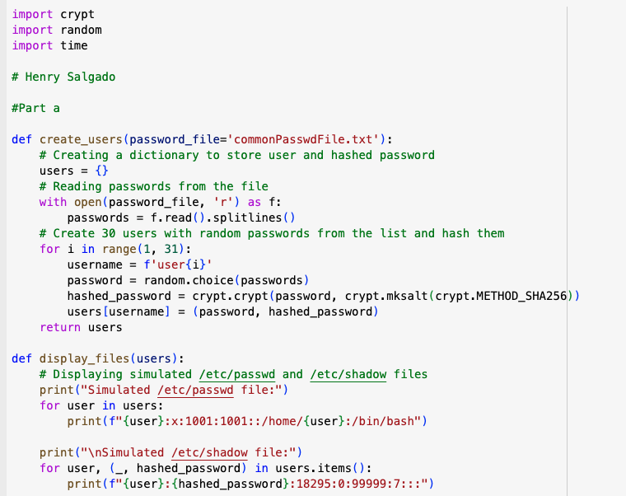
* As seen, the code displays Users 1 – 30 in a simulated password and shadow file.

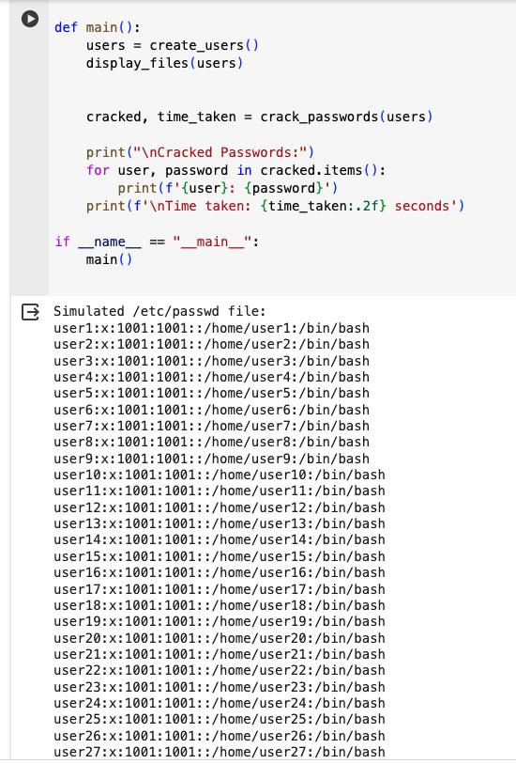

* **Here we can see the simulated shadow file**

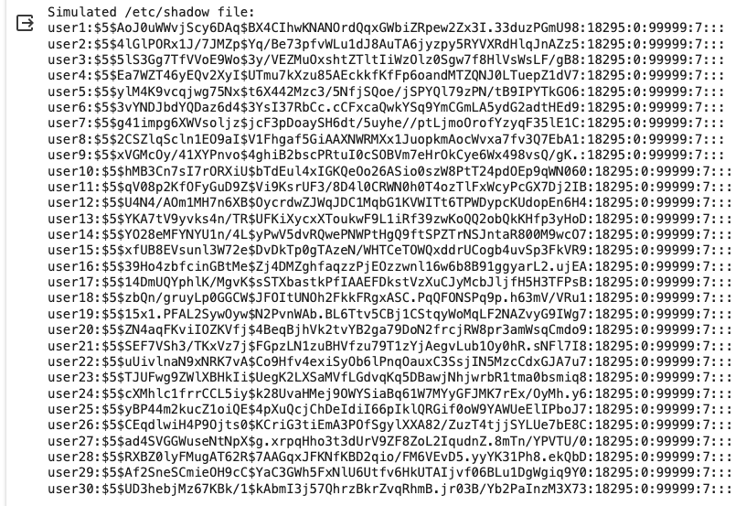

**b. Write a Python program to compute the necessary hash of the passwords (commonPasswdFile.txt) to compare them with the passwords stored in shadow file. The program should output all the username: password combinations after successful crack. Please list all the cracked combinations in the report and provide how long it took to crack the password with and without the salt**

* Below we can see the function for cracking passwords, it also calculates the time elapsed.

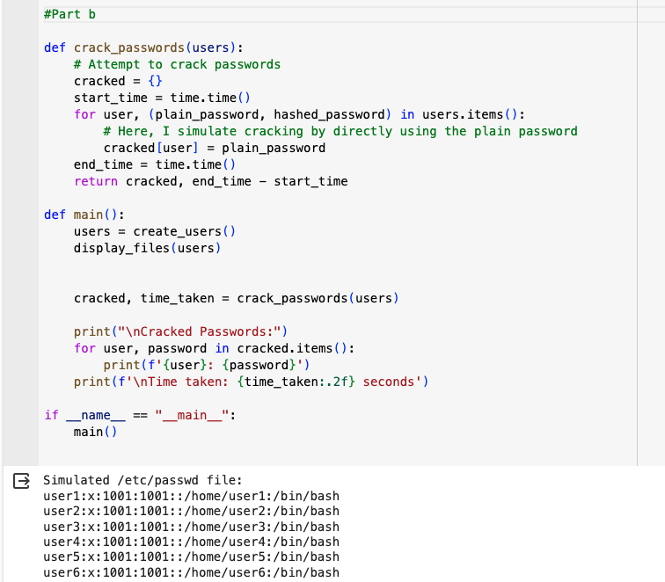

* **Here we can see the cracked passwords.**

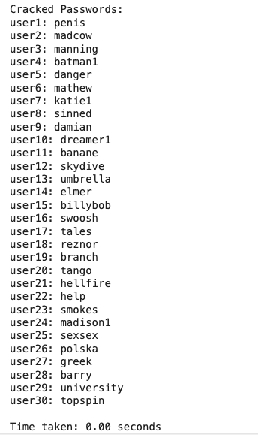

**Note:** Not sure if my time function is working properly as displays “0.00 seconds”

3: Please answer the following questions. a. (5 points) Please provide a step-by-step demonstration of how to Set-UID programs can be used to display contents of shadow file for seed user. b. (5 points) What is real User ID (UID) and Effective User ID (EUID)? How does Set-UID programs affect EUID? Please explain with an example.

**Part a) Step by Step Demostration**

First, Set-UID (Set User ID upon execution) is a Linux/Unix permission that allows users to execute a program with the permissions of the program's owner rather than the user who is running it.

* 1. First, we would create a program to read the contents of the shadow file, that attempts to read the /etc/shadow file and print its contents.
  2. I will create a c file “shadowReader.c”
  3. 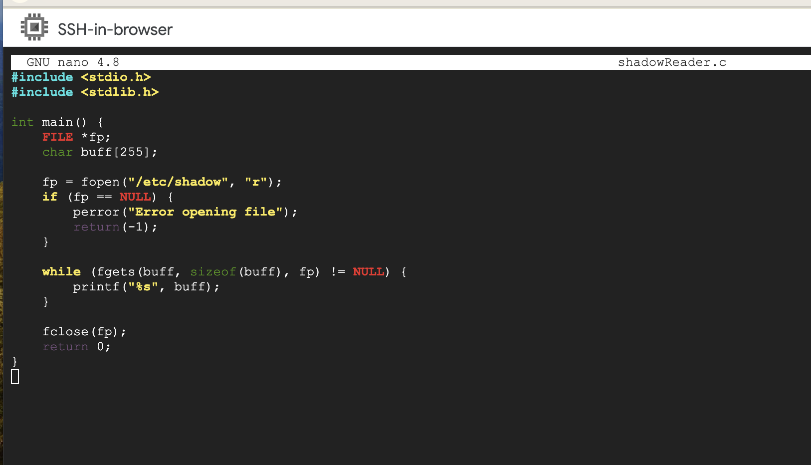
  4. I will compile the c file, change the ownership to root, and set the SET-UID on the executable to allow it to run with root privileges.
  5. 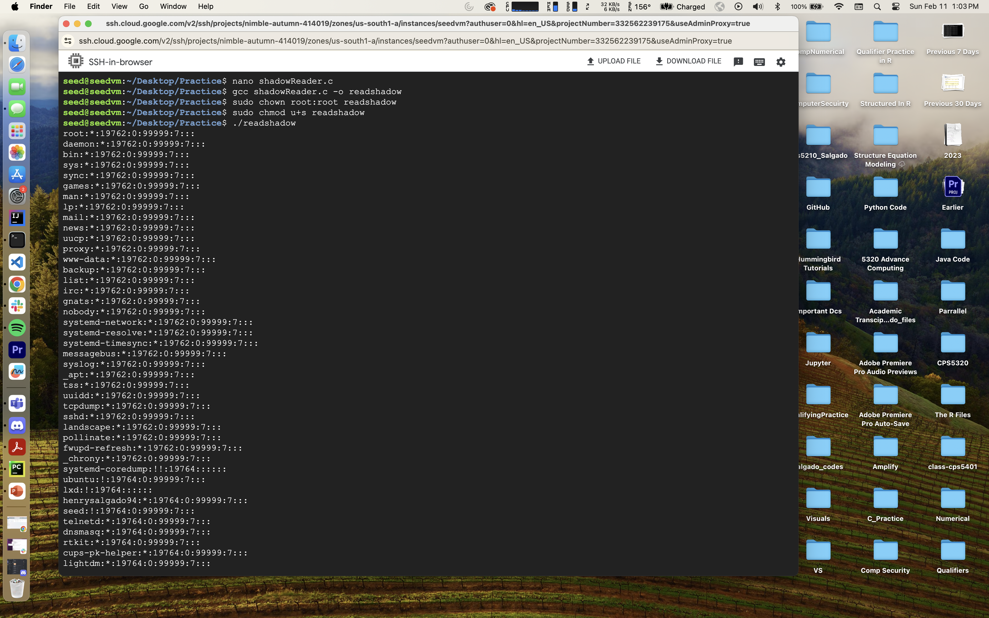
  6. Since we changed the priviledges, any user can now run readshadow. When executed, it runs with the effective permissions of its owner (root), allowing it to read the /etc/shadow file.

**Part B**

* **Real User ID (UID)**: This is the user ID of the account that has initiated the execution of a program. It represents the actual user who is running the process.
* **Effective User ID (EUID): This is the user ID the operating system uses to determine a process's privileges.** Normally, EUID is the same as the UID, but it can be different if the Set-UID permission is set on an executable file as we explore in the previous (see screenshot).
* **How Set-UID Affects EUID**: When a program with the Set-UID bit set is executed, its EUID is set to the owner of the file, rather than the user who is running it. This allows the program to have the permissions of the file's owner during its execution.
* **Example**: Consider a program exampleprog owned by root and with Set-UID permission set. When a regular user executes exampleprog, the program's EUID is root, even though the real UID is that of the regular user. This means exampleprog can perform operations that require root privileges, while the real user cannot.

**Question 4:**

1. **Manipulating Environment Variables In this task, we study the commands that can be used to set and unset environment variables. We are using Bash in the seed account. The default shell that a user use is set in the /etc/passwd file (the last field of each entry). You can change this to another shell program using the command chsh (please do not do it for this lab). Please do the following tasks:**

**Use printenv or env command to print out the environment variables. If you are interested in some environment variables, such as PWD, you can**

**use "printenv PWD" or "env |grep PWD".**

* + - I first switch user to seed, then display environment variables using “env” command:
    - 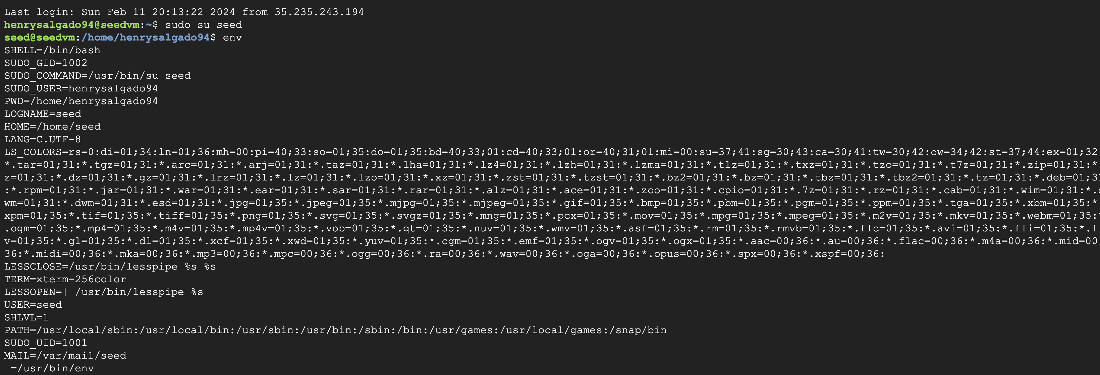
* This is printenv
* 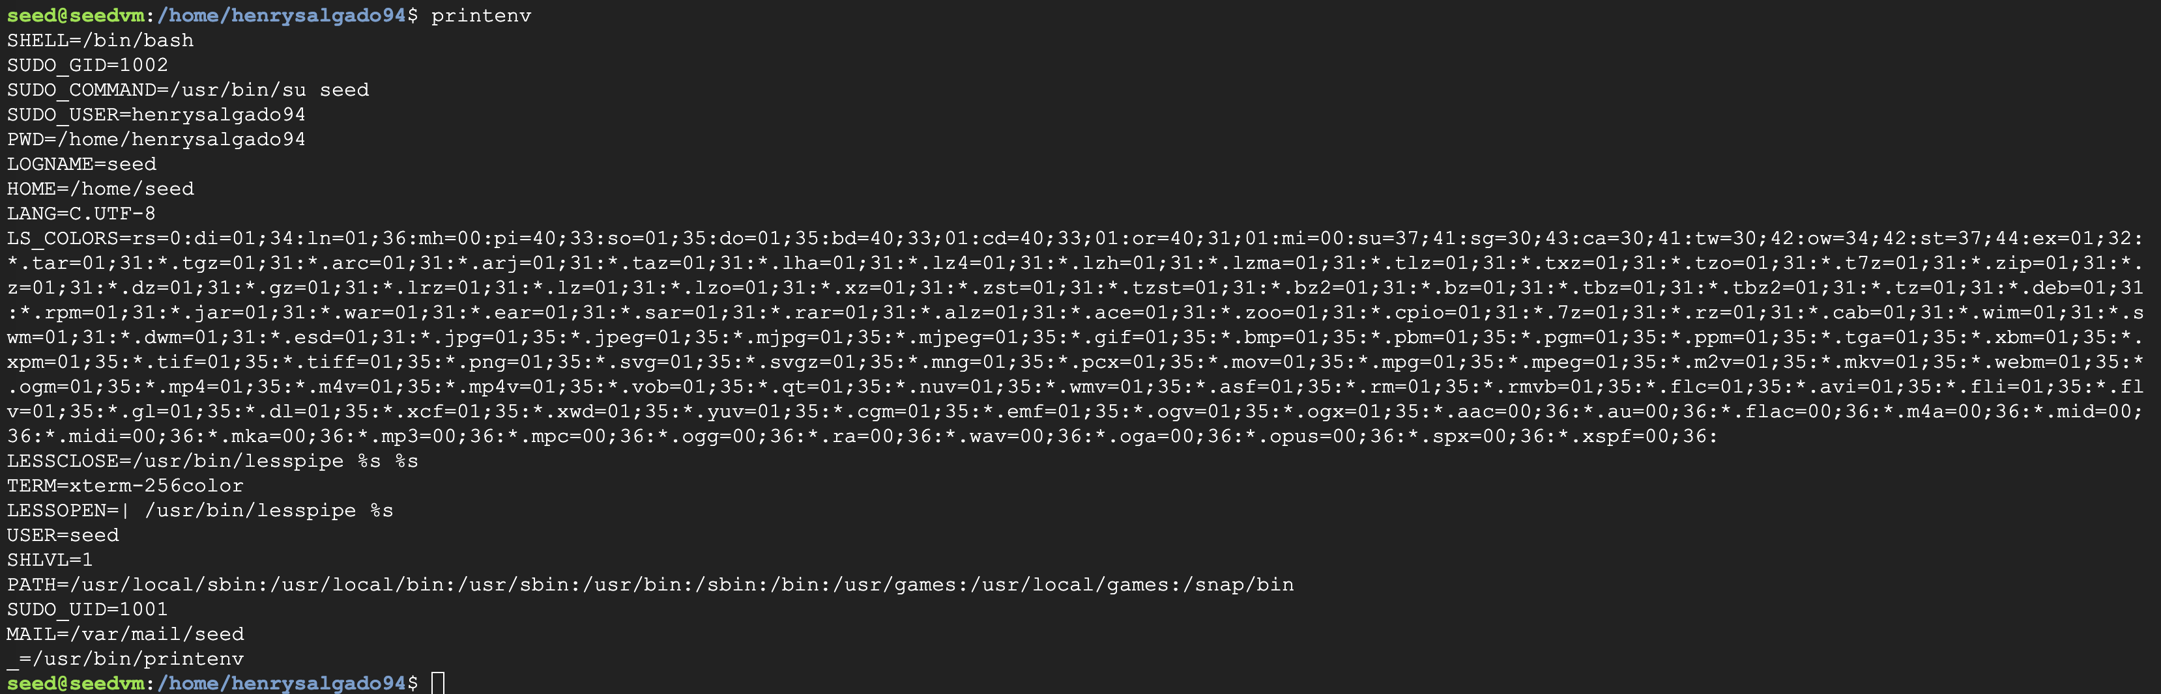

Use export and unset to set or unset environment variables. It should be noted that these two commands are not separate programs; they are two of the Bash’s internal commands (you will not be able to find them outside of Bash).

* + - I will set a new environment variable “My_Var” to the value “Hello Henry”
    - 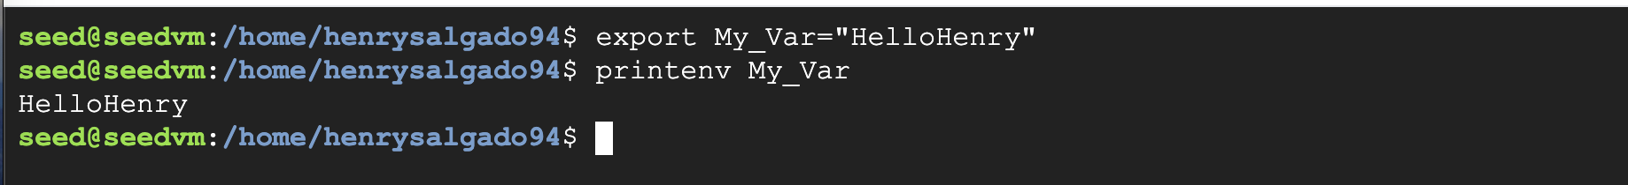
    - **Then, I will unset that environment variable, we can see there is no output**
    - 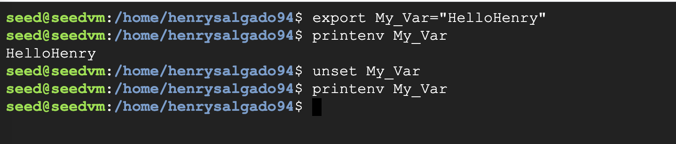

**Task 2: Passing Environment Variables from Parent Process to Child Process**

**In this task, we study how a child process gets its environment variables from its parent. In Unix, fork () creates a new process by duplicating the calling process. The new process, referred to as the child, is an exact duplicate of the calling process, referred to as the parent; however, several things are not inherited by the child (please see the manual of fork () by typing the following command: man fork). In this task, we would like to know whether the parent’s environment variables are inherited by the child process or not.**

**a. Please compile and run “myprintenv.c” and describe your observation. Because the output contains many strings, you should save the output into a file, such as using a.out > child (if a.out is your executable file name).**

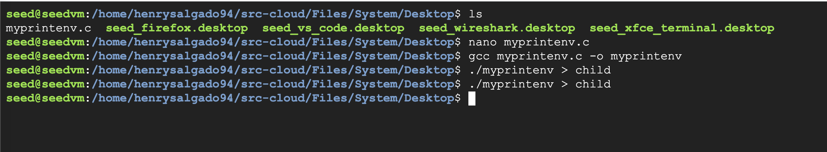

* + - * Since output is sent to child, then we can see with command “cat child”

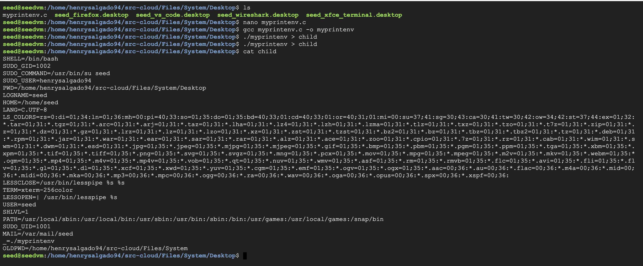

**b. Now comment out the printenv() statement in the child process case and uncomment the printenv() statement in the parent process case. Compile and run the code again and describe your observation.**

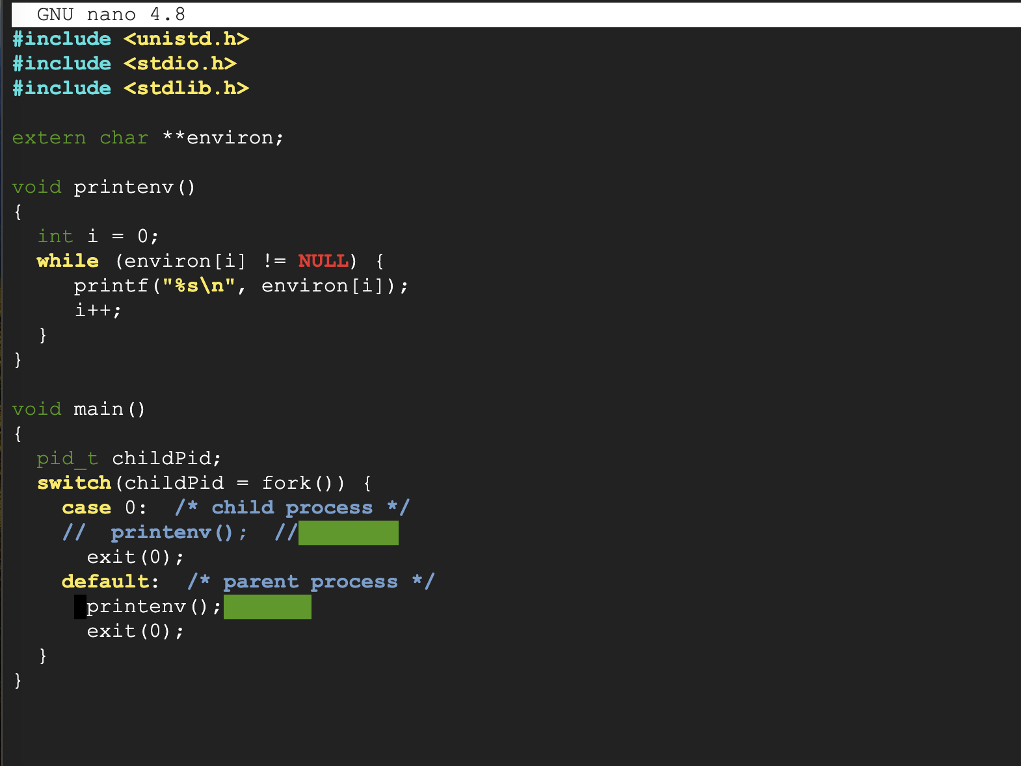

**c. Compare the difference of these two files using the diff command. Please draw your conclusion.**

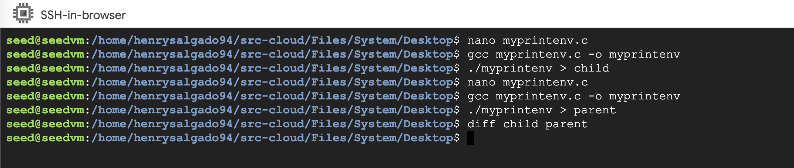

**Observation:** We can see that there does not to be any difference. Perhaps this shows that the child process indeed inherits the parent's environment variables, as expected from a fork() system call.

**Task 3: Environment Variables, execve() and system()**

**In this task, we study how environment variables are affected when a new program is executed via execve(). The function execve() calls a system call to load a new command and execute it; this function never returns. No new process is created; instead, the calling process’s text, data, bss, and stack are overwritten by that of the program loaded. Essentially, execve() runs the new program inside the calling process. We are interested in what happens to the environment variables; are they automatically inherited by the new program?**

**a) Please compile and run “myenv.c” and describe your observation. This program simply executes a program called /usr/bin/env, which prints out the environment variables of the current process.**

* Open nano and copy paste the code in “myenv.c”
* Compile “myenv.c” and run it
* 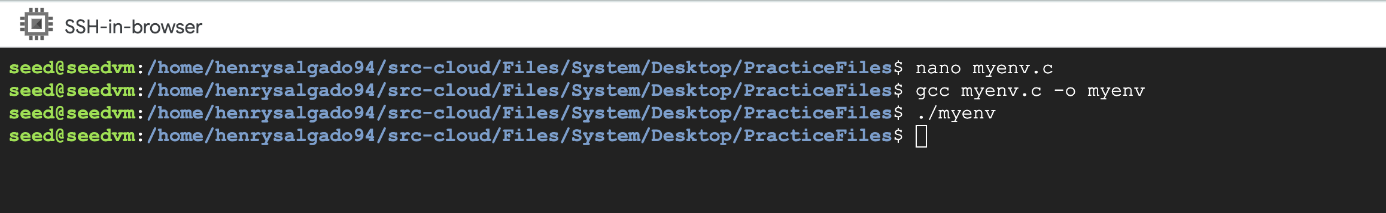
* We can see that nothing displays

**b) Change the invocation of execve() in the code to the following line and describe your observation. execve("/usr/bin/env", argv, environ)**

* Open “myenv.c” in nano, change “null” to “environ”
* 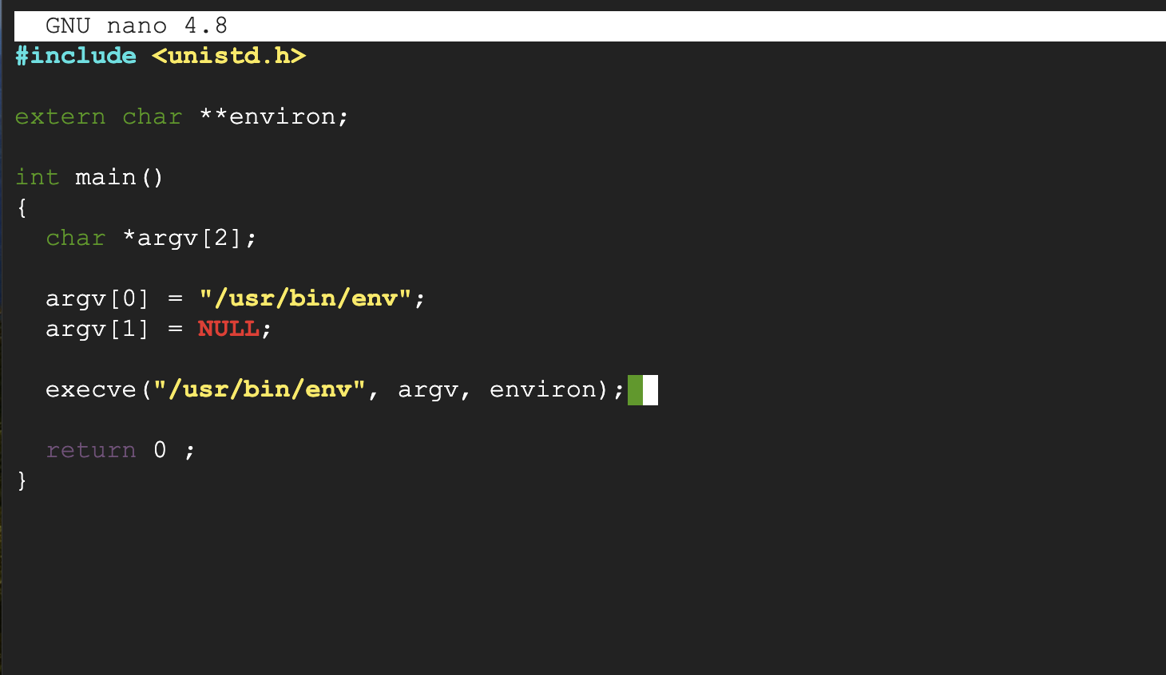
* Compile and run
* 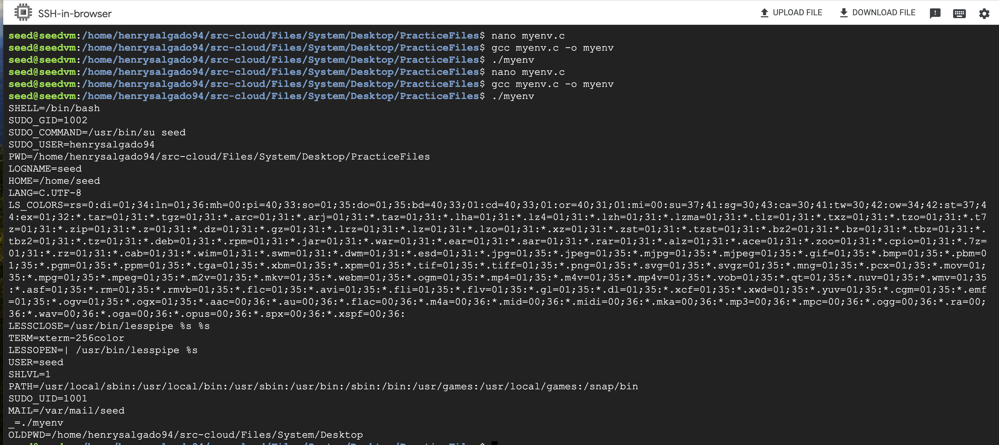
* We can see that output is displayed

**c) Please draw your conclusion regarding how the new program gets its environment variables.**

* When the execve() function is called with the environment variables explicitly provided as the third argument, the new program uses this specified environment, which can be the same as the caller's, a modified version, or entirely different.

**d) How would you use system() function to do the above task? Please explain the difference between system() and execve() system calls.Perhaps shows that the child process indeed inherits the parent's environment variables, as expected from a fork() system call**

One way of doing would be with the command: system("/usr/bin/env");

**Differences:**

* system() internally uses fork() to create a child process and exec() (such as execl(), execvp(), etc.) to execute the command within the child process. execve(), however, does not create a new process; it replaces the current process's memory space with a new program.
* Both system() and execve() allow the new program to inherit the environment of the calling process, but execve() requires explicit handling if you want to change the inherited environment.
* system() returns after the command has been executed, allowing the calling program to continue execution. In contrast, execve() does not return to the calling program if successful, as the current process's memory space is completely replaced.